**Appendix I**

**Flipkart Shopping**

**PROJECT REPORT**

***Submitted by***

**Mohd Usman**

**[Reg No. 12410824]**

***GitHub Link:*** https://github.com/usmanmohd112/usman.git

***in partial fulfillment for the award of the degree***

***of***

**Bachelor of Technology**

**IN**

**Computer Science and Engineering**



**Lovely Professional University, Punjab**

**October 2024**

**APPENDIX II**

**Lovely Professional University, Punjab**

**BONAFIDE CERTIFICATE**

**<Font Style Times New Roman – size -16>**

**<Font Style Times New Roman – size -14>**

**Certified that this project report Flipkart Shopping**

**is the Bonafide work of Mohd Usman**

**who carried out the project work under my supervision.**

**<<Signature of the Supervisor>>  
SIGNATURE  
<<Name>>**

**SUPERVISOR**

**<<Full address of the Dept. & Organization>>**

**<<Signature of the Mentor>>**

**SIGNATURE**

**<<Name>>  
CLASS MENTOR**

**<<Signature of the Head of the Department>>**

**SIGNATURE**

**<<Name>>  
HEAD OF THE DEPARTMENT**

**APPENDIX III**

**TABLE OF CONTENTS**

|  |  |  |
| --- | --- | --- |
| **Sr. NO.** | **Content** | **PAGE NO.** |
| **1** | **Title Page** | **i** |
| **4** | **Table of Contents** | **ii** |
| **3** | **Introduction** | **iii** |
| **4** | **Technology Used** | **iv-v** |
| **5** | **Workflow** | **vi** |
| 6 | **Working of Project** | vii |
| 7 | **Code Snippets of the project** | viii-xxiv |
| 8 | **Screenshots** | xxv-xxviii |
| 9 | **Conclusion** | xxix |
| 10 | Reference | xxx |
|  |  |  |

|  |  |  |  |
| --- | --- | --- | --- |
|  |  |  |  |

**Introduction**

**Flipkart** is one of India’s largest and most popular e-commerce platforms, offering a wide variety of products ranging from electronics, fashion, home essentials, books, and more. Founded in 2007 by Sachin Bansal and Binny Bansal, Flipkart has revolutionized the online shopping experience in India by providing convenient access to a vast array of products from top brands at competitive prices.

Customers can shop via Flipkart's user-friendly website or mobile app, enjoy a secure payment process, and benefit from fast delivery options, including express and same-day shipping. Flipkart also features seasonal sales, discounts, and offers, making it a go-to destination for online shoppers across the country.

With its focus on customer satisfaction, Flipkart offers various services like easy returns, cash on delivery, and customer support, further strengthening its position as a leading player in India’s e-commerce space.

**TECHNOLOGIES USED**

Creating an engaging and functional e-commerce website like Gaming Sphere involves utilizing a combination of technologies. In this case, HTML, CSS, and JavaScript serve as the foundational building blocks of the website, each contributing unique features and functionalities that enhance user experience.

**HTML (Hyper Text Markup Language)**

HTML is the backbone of any website, providing the structure and semantic meaning to web content. In Gaming Sphere, HTML is used to create the layout of the site, including the homepage, product listings, and checkout pages. Key features include:

1. **Semantic Elements**: Utilizing elements like <header>, <nav>, <section>, and <footer> helps improve the site's accessibility and SEO (Search Engine Optimization). This organization allows search engines to better understand the content and context of the page.
2. **Forms and Inputs**: HTML forms are critical for user interactions, such as creating accounts, logging in, and processing purchases. By using various input types (e.g., text, email, number), the site ensures that user data is collected efficiently.
3. **Multimedia Integration**: HTML supports embedding images, videos, and audio files, allowing Gaming Sphere to showcase game trailers, screenshots, and product details effectively.

**CSS (Cascading Style Sheets)**

CSS is responsible for the presentation and layout of the website. It defines how HTML elements are displayed on the screen, enhancing the visual appeal and user experience. Key contributions of CSS in Gaming Sphere include:

1. **Styling and Layout**: CSS is used to create visually appealing designs with custom fonts, colours, and spacing. The responsive design ensures that the website looks great on various devices, from desktops to smartphones.
2. **Flexbox and Grid Systems**: These CSS features allow for flexible and responsive layouts. By using Flexbox for navigation and Grid for product listings, the site adapts seamlessly to different screen sizes, providing an optimal browsing experience.
3. **Animations and Transitions**: CSS enables subtle animations and transitions that enhance interactivity, such as hover effects on buttons and smooth loading animations, making the user experience more engaging.

WORKFLOW

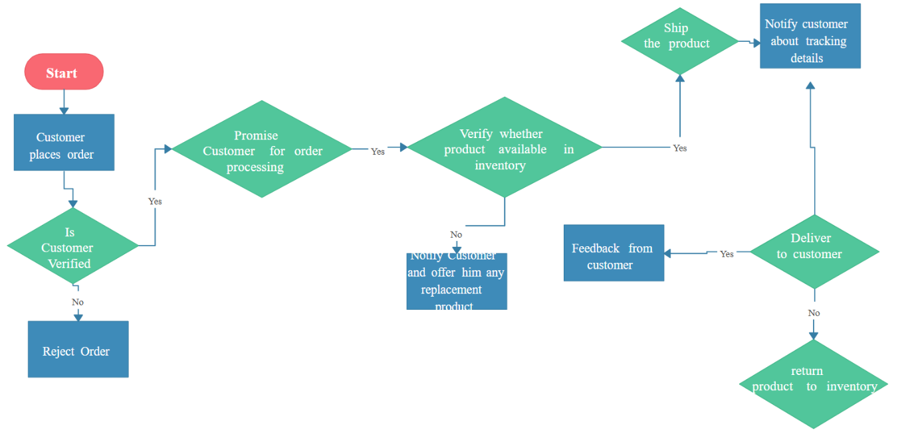

**WORKING**

Flipkart operates as an e-commerce marketplace, connecting buyers and sellers through its online platform. Here's a breakdown of how Flipkart works:

**1. Platform Structure:**

* **Marketplace Model**: Flipkart follows a marketplace model, meaning it acts as an intermediary between sellers and buyers. While Flipkart itself sells some products (through its own warehouses), it primarily allows third-party sellers to list and sell their products on the platform.
* **Product Listings**: Sellers list their products on Flipkart’s website or app. Each listing includes detailed product information, images, pricing, and availability. Flipkart offers tools to help sellers manage their inventory, pricing, and promotions.

**2. Product Search and Browsing:**

* **Categories**: Flipkart offers a broad range of categories such as electronics, fashion, home appliances, books, furniture, and groceries. Users can browse through different categories or use the search bar to find specific items.
* **Filters and Sorting**: Users can filter products by price, ratings, brand, and other specifications, and sort them by relevance, popularity, or price.

**3. Order Placement:**

* **Add to Cart**: Once a customer selects a product, they can add it to their shopping cart. Multiple items can be added to the cart before proceeding to checkout.
* **Checkout Process**: When ready to purchase, customers proceed to the checkout page where they enter their shipping address, select a payment method, and confirm the order.

***Code Snippets***

***Mywebsite.html***

***<!DOCTYPE html>***

***<html lang="en">***

***<head>***

***<meta charset="UTF-8">***

***<meta name="viewport" content="width=device-width, initial-scale=1.0">***

***<title>Flipkart Clone</title>***

***<link rel="stylesheet" href="styles.css">***

***</head>***

***<body>***

***<!-- Navbar -->***

***<header class="navbar">***

***<div class="logo">Flipkart</div>***

***<nav class="nav-links">***

***<ul>***

***<li><a href="categories.html">Categories</a></li>***

***<li><a href="products.html">Products</a></li>***

***<li><a href="offers.html">Offers</a></li>***

***</ul>***

***</nav>***

***<div class="search-bar">***

***<input type="text" placeholder="Search for products">***

***<button>Search</button>***

***</div>***

***</header>***

***<!-- Categories Section -->***

***<section class="categories" id="categories">***

***<h2>Shop by Category</h2>***

***<div class="category-grid">***

***<div class="category-card">***

***<img src="https://www.livehindustan.com/lh-img/uploadimage/library/2023/09/01/16_9/16_9_6/electronics_sale_flipkart_sale_1693541481.jpg" alt="Electronics">***

***<p>Electronics</p>***

***</div>***

***<div class="category-card">***

***<img src="2a59f639da774d27b9a421e41c8d3101.webp" alt="Clothing">***

***<p>Clothing</p>***

***</div>***

***<div class="category-card">***

***<img src="download.jpg" alt="Home Appliances">***

***<p>Home Appliances</p>***

***</div>***

***</div>***

***</section>***

***<!-- Products Section -->***

***<section class="products" id="products">***

***<h2>Top Deals</h2>***

***<div class="product-grid">***

***<div class="product-card">***

***<img src="images.jpg" alt="Laptop">***

***<h3>Laptop</h3>***

***<p>$800</p>***

***</div>***

***<div class="product-card">***

***<img src="download (1).jpg" alt="Smartphone">***

***<h3>Smartphone</h3>***

***<p>$500</p>***

***</div>***

***<div class="product-card">***

***<img src="download (2).jpg" alt="Television">***

***<h3>Television</h3>***

***<p>$600</p>***

***</div>***

***</div>***

***</section>***

***<!-- Footer -->***

***<footer>***

***<p>&copy; 2024 Flipkart Website. All rights reserved.</p>***

***</footer>***

***</body>***

***</html>***

***Mywebsite.css***

***/* General Styles */***

***body {***

***margin: 0;***

***font-family: Arial, sans-serif;***

***}***

***/* Navbar */***

***.navbar {***

***display: flex;***

***justify-content: space-between;***

***align-items: center;***

***background: #2874f0;***

***color: white;***

***padding: 10px 20px;***

***}***

***.logo {***

***font-size: 24px;***

***font-weight: bold;***

***}***

***.nav-links ul {***

***list-style: none;***

***display: flex;***

***gap: 15px;***

***margin: 0;***

***padding: 0;***

***}***

***.nav-links a {***

***text-decoration: none;***

***color: white;***

***}***

***.search-bar {***

***display: flex;***

***align-items: center;***

***gap: 5px;***

***}***

***.search-bar input {***

***padding: 5px;***

***border: none;***

***border-radius: 4px;***

***}***

***.search-bar button {***

***padding: 5px 10px;***

***border: none;***

***background: #ff9f00;***

***color: white;***

***border-radius: 4px;***

***cursor: pointer;***

***}***

***/* Categories Section */***

***.categories {***

***text-align: center;***

***padding: 20px;***

***background: #f1f1f1;***

***}***

***.category-grid {***

***display: flex;***

***justify-content: center;***

***gap: 20px;***

***}***

***.category-card {***

***background: white;***

***border-radius: 8px;***

***padding: 10px;***

***width: 150px;***

***text-align: center;***

***box-shadow: 0 4px 6px rgba(0, 0, 0, 0.1);***

***}***

***.category-card img {***

***max-width: 100%;***

***border-radius: 8px;***

***}***

***/* Products Section */***

***.products {***

***padding: 20px;***

***}***

***.product-grid {***

***display: flex;***

***justify-content: center;***

***gap: 20px;***

***flex-wrap: wrap;***

***}***

***.product-card {***

***background: white;***

***border-radius: 8px;***

***padding: 10px;***

***width: 200px;***

***text-align: center;***

***box-shadow: 0 4px 6px rgba(0, 0, 0, 0.1);***

***}***

***.product-card img {***

***max-width: 100%;***

***border-radius: 8px;***

***}***

***/* Footer */***

***footer {***

***text-align: center;***

***background: #2874f0;***

***color: white;***

***padding: 10px 0;***

***}***

***Categories***

***<!DOCTYPE html>***

***<html lang="en">***

***<head>***

***<meta charset="UTF-8">***

***<meta name="viewport" content="width=device-width, initial-scale=1.0">***

***<title>Flipkart Categories</title>***

***<style>***

***body {***

***font-family: Arial, sans-serif;***

***}***

***.category-list {***

***list-style-type: none;***

***padding: 0;***

***}***

***.category-item {***

***background-color: #f8f8f8;***

***margin: 5px 0;***

***padding: 10px;***

***border: 1px solid #ddd;***

***}***

***.category-item a {***

***text-decoration: none;***

***color: #333;***

***font-size: 16px;***

***}***

***.category-item a:hover {***

***color: #0066cc;***

***}***

***</style>***

***</head>***

***<body>***

***<h1>Browse Flipkart Categories</h1>***

***<ul class="category-list">***

***<li class="category-item"><a href="#">Electronics</a></li>***

***<li class="category-item"><a href="#">Fashion</a></li>***

***<li class="category-item"><a href="#">Home & Furniture</a></li>***

***<li class="category-item"><a href="#">Beauty & Personal Care</a></li>***

***<li class="category-item"><a href="#">Books</a></li>***

***<li class="category-item"><a href="#">Sports & Fitness</a></li>***

***<li class="category-item"><a href="#">Toys</a></li>***

***<!-- Add more categories as needed -->***

***</ul>***

***</body>***

***</html>***

***Products***

***<!DOCTYPE html>***

***<html lang="en">***

***<head>***

***<meta charset="UTF-8">***

***<meta name="viewport" content="width=device-width, initial-scale=1.0">***

***<title>Flipkart Product List</title>***

***<style>***

***body {***

***font-family: Arial, sans-serif;***

***background-color: #f7f7f7;***

***margin: 0;***

***padding: 0;***

***}***

***.container {***

***max-width: 1200px;***

***margin: 0 auto;***

***padding: 20px;***

***}***

***h1 {***

***text-align: center;***

***color: #333;***

***}***

***.product-list {***

***display: flex;***

***flex-wrap: wrap;***

***justify-content: space-between;***

***gap: 20px;***

***}***

***.product-item {***

***background-color: #fff;***

***border: 1px solid #ddd;***

***padding: 15px;***

***width: 250px;***

***box-shadow: 0 2px 5px rgba(0, 0, 0, 0.1);***

***text-align: center;***

***transition: transform 0.3s ease;***

***}***

***.product-item img {***

***width: 100%;***

***height: auto;***

***margin-bottom: 10px;***

***}***

***.product-item h3 {***

***font-size: 18px;***

***color: #333;***

***margin-bottom: 10px;***

***}***

***.product-item p {***

***color: #777;***

***font-size: 14px;***

***margin-bottom: 15px;***

***}***

***.product-item a {***

***text-decoration: none;***

***color: #fff;***

***background-color: #ff3e3e;***

***padding: 10px;***

***border-radius: 5px;***

***display: inline-block;***

***}***

***.product-item a:hover {***

***background-color: #e63333;***

***}***

***.product-item:hover {***

***transform: scale(1.05);***

***}***

***</style>***

***</head>***

***<body>***

***<div class="container">***

***<h1>Flipkart Product List</h1>***

***<div class="product-list">***

***<!-- Product 1 -->***

***<div class="product-item">***

***<img src="download (3).jpg" alt="Product 1">***

***<h3>Product Name 1</h3>***

***<p>Brief description of Product 1. Great features and amazing value.</p>***

***<a href="https://www.flipkart.com/product1" target="_blank">Buy Now</a>***

***</div>***

***<!-- Product 2 -->***

***<div class="product-item">***

***<img src="98f4b3b232ccc5df51217f78344719a9.webp" alt="Product 2">***

***<h3>Product Name 2</h3>***

***<p>Brief description of Product 2. Excellent performance and stylish design.</p>***

***<a href="https://www.flipkart.com/product2" target="_blank">Buy Now</a>***

***</div>***

***<!-- Product 3 -->***

***<div class="product-item">***

***<img src="download (4).jpg" alt="Product 3">***

***<h3>Product Name 3</h3>***

***<p>Brief description of Product 3. Affordable price with premium features.</p>***

***<a href="https://www.flipkart.com/product3" target="_blank">Buy Now</a>***

***</div>***

***<!-- Product 4 -->***

***<div class="product-item">***

***<img src="images (1).jpg" alt="Product 4">***

***<h3>Product Name 4</h3>***

***<p>Brief description of Product 4. High quality and top-rated.</p>***

***<a href="https://www.flipkart.com/product4" target="_blank">Buy Now</a>***

***</div>***

***<!-- Product 5 -->***

***<div class="product-item">***

***<img src="images.jpg" alt="Product 5">***

***<h3>Product Name 5</h3>***

***<p>Brief description of Product 5. Popular choice for its value and durability.</p>***

***<a href="https://www.flipkart.com/product5" target="_blank">Buy Now</a>***

***</div>***

***</div>***

***</div>***

***</body>***

***</html>***

***Offers***

***<!DOCTYPE html>***

***<html lang="en">***

***<head>***

***<meta charset="UTF-8">***

***<meta name="viewport" content="width=device-width, initial-scale=1.0">***

***<title>Flipkart Offers</title>***

***<style>***

***body {***

***font-family: Arial, sans-serif;***

***background-color: #f7f7f7;***

***margin: 0;***

***padding: 0;***

***}***

***.container {***

***max-width: 1200px;***

***margin: 0 auto;***

***padding: 20px;***

***}***

***h1 {***

***text-align: center;***

***color: #333;***

***}***

***.offer-list {***

***display: flex;***

***flex-wrap: wrap;***

***justify-content: space-between;***

***gap: 20px;***

***}***

***.offer-item {***

***background-color: #fff;***

***border: 1px solid #ddd;***

***padding: 15px;***

***width: 250px;***

***box-shadow: 0 2px 5px rgba(0, 0, 0, 0.1);***

***text-align: center;***

***transition: transform 0.3s ease;***

***}***

***.offer-item img {***

***width: 100%;***

***height: auto;***

***margin-bottom: 10px;***

***}***

***.offer-item h3 {***

***font-size: 18px;***

***color: #333;***

***margin-bottom: 10px;***

***}***

***.offer-item p {***

***color: #777;***

***font-size: 14px;***

***margin-bottom: 15px;***

***}***

***.offer-item a {***

***text-decoration: none;***

***color: #fff;***

***background-color: #ff3e3e;***

***padding: 10px;***

***border-radius: 5px;***

***display: inline-block;***

***}***

***.offer-item a:hover {***

***background-color: #e63333;***

***}***

***.offer-item:hover {***

***transform: scale(1.05);***

***}***

***</style>***

***</head>***

***<body>***

***<div class="container">***

***<h1>Current Flipkart Offers</h1>***

***<div class="offer-list">***

***<!-- Offer 1 -->***

***<div class="offer-item">***

***<img src="download (6).jpg" alt="Offer 1">***

***<h3>Flat 50% Off on Electronics</h3>***

***<p>Get up to 50% off on select electronics like smartphones, laptops, and accessories.</p>***

***<a href="https://www.flipkart.com/offers/electronics" target="_blank">Shop Now</a>***

***</div>***

***<!-- Offer 2 -->***

***<div class="offer-item">***

***<img src="download (7).jpg" alt="Offer 2">***

***<h3>Extra 10% Cashback on Fashion</h3>***

***<p>Avail an extra 10% cashback on fashion items when you pay via Flipkart Pay Later.</p>***

***<a href="https://www.flipkart.com/offers/fashion" target="_blank">Shop Now</a>***

***</div>***

***<!-- Offer 3 -->***

***<div class="offer-item">***

***<img src="download (8).jpg" alt="Offer 3">***

***<h3>Flat ₹1000 Off on Smartphones</h3>***

***<p>Exclusive discount on the latest smartphones. Get ₹1000 off on select models.</p>***

***<a href="https://www.flipkart.com/offers/smartphones" target="_blank">Shop Now</a>***

***</div>***

***<!-- Offer 4 -->***

***<div class="offer-item">***

***<img src="images (2).jpg" alt="Offer 4">***

***<h3>Up to 40% Off on Home Appliances</h3>***

***<p>Shop for home appliances with up to 40% off. Limited period offer.</p>***

***<a href="https://www.flipkart.com/offers/home-appliances" target="_blank">Shop Now</a>***

***</div>***

***</div>***

***</div>***

***</div>***

***</body>***

***</html>***

***Website output:***

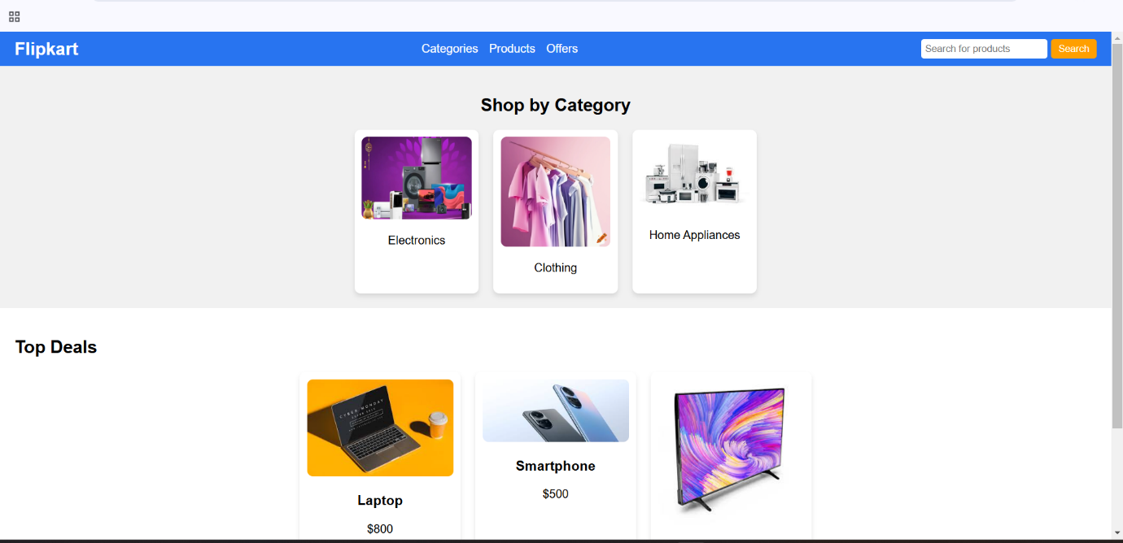

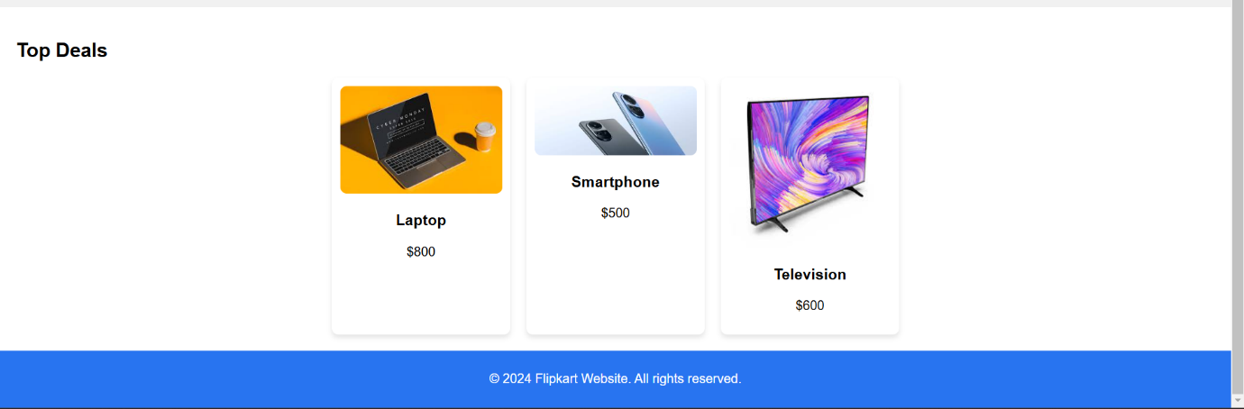

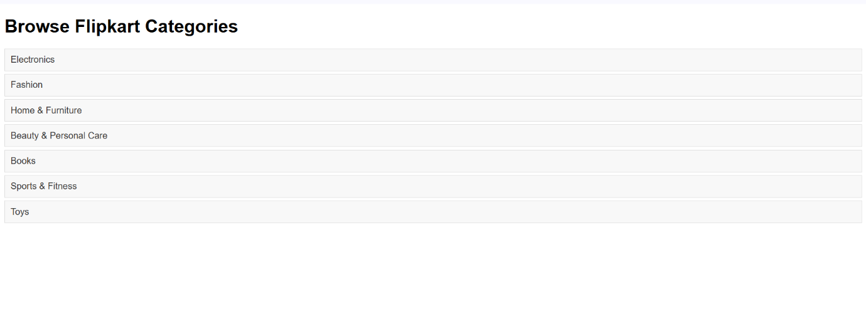

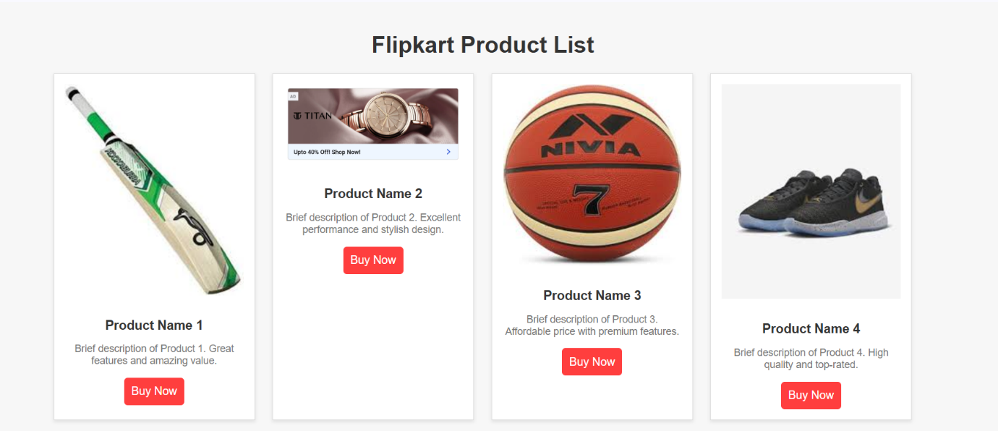

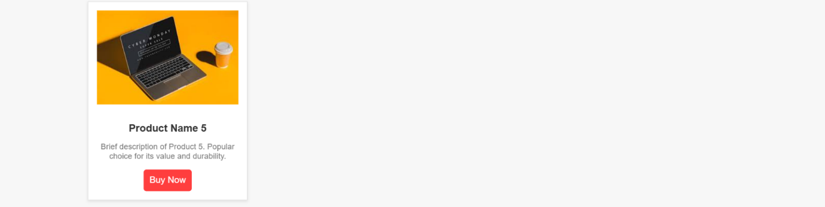

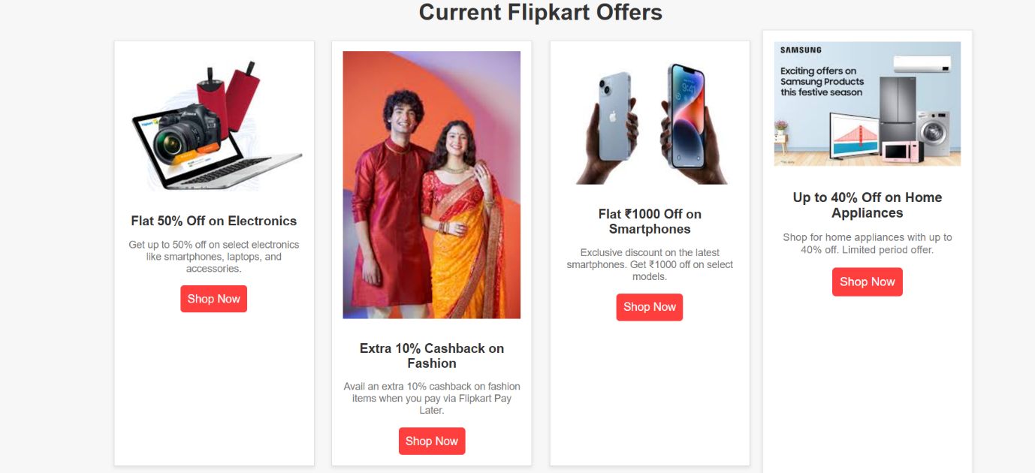

**CONCLUSION**

Flipkart has revolutionized the way people shop in India, making online shopping more accessible, convenient, and reliable. With its wide range of products, user-friendly interface, and efficient delivery systems, Flipkart has established itself as one of the leading e-commerce platforms in the country. Whether you're shopping for electronics, fashion, home goods, or groceries, Flipkart provides a seamless experience from browsing to delivery.

Its focus on customer satisfaction, including features like easy returns, multiple payment options, and regular discounts and sales, has helped build trust among millions of shoppers. Additionally, its marketplace model supports both large brands and small businesses, offering a diverse range of products at competitive prices.

With continued innovation in technology, logistics, and customer service, Flipkart is well-positioned to maintain its leadership in the e-commerce space, providing a convenient and enjoyable shopping experience for customers across India. Whether you're a first-time buyer or a regular shopper, Flipkart’s wide selection, secure shopping environment, and frequent deals make it a go-to destination for online shopping.

REFRENCES

1. W3Schools - For foundational HTML, CSS, and JavaScript tutorials and examples.

2. For in-depth documentation on HTML, CSS, and JavaScript.

3. ChatGPT by OpenAI - For guidance, suggestions, and code refinement throughout the project.